**BIRUNGI PATIENCE 2016 BIT 082PS**

**Publishing Android Application on Google play**

Android application publishing is a process that makes your Android applications available to users. Infect, publishing is the last phase of the Android application development process.

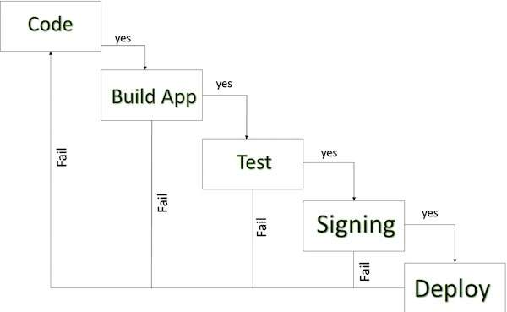

**Export Android Application Process .**

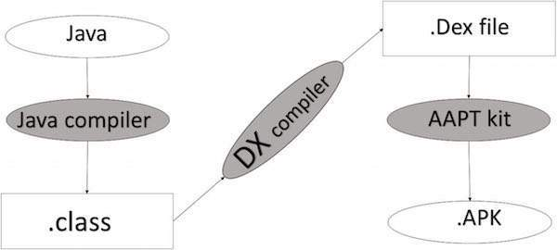

**APK DEVELOPMENT PROCESS**

* **DX Tools** (Dalvik executable tools): It going to convert **.class file** to **.dex file**. it has useful for memory optimization and reduce the boot-up speed time
* **AAPT**(Android assistance packaging tool):it has useful to convert **.Dex file**to**.Apk**
* **APK** (Android packaging kit): The final stage of deployment process is called as .apk.

You will need to export your application as an APK (Android Package) file before you upload it Google Play marketplace.

**EXPORTING AN APPLICATION AS APK**

To export an application, just open that application project in Android studio and select **Build → Generate Signed APK** from your Android studio and follow the simple steps to export your application −

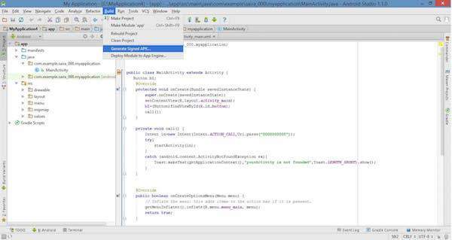

Next select, **Generate Signed APK** option as shown in the above screen shot and then click it so that you get following screen where you will choose **Create new keystore** to store your application.

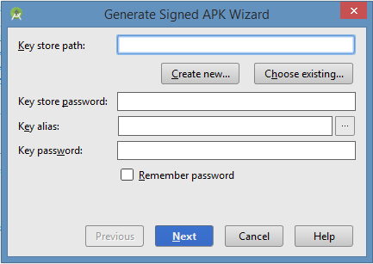

Enter your key store path, key store password, key alias and key password to protect your application and click on **Next** button once again. It will display following screen to let you create an application −

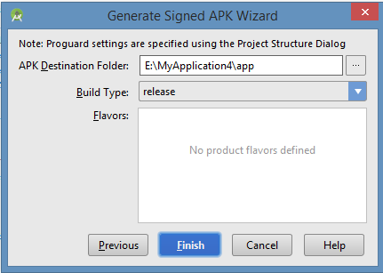

Once you filled up all the information, like app destination, build type and flavours click **finish** button while creating an application it will show as below

Creating Application

Finally, it will generate your Android Application as APK format File which will be uploaded at Google Play marketplace.

**Steps for Publishing Android Application on Google play**

1. **Create an account**

Firstly to publish your app on Google play store, you need to have account on Google. You may have already personal email account with them but for your app it's better to separate one for manage your apps easily. You would have to pay a registration fees of 25 USD, using Google payments, While registering your publisher account. After that, a verification mail would be sent to you and then you sign in to your developer console, where all action would take place.

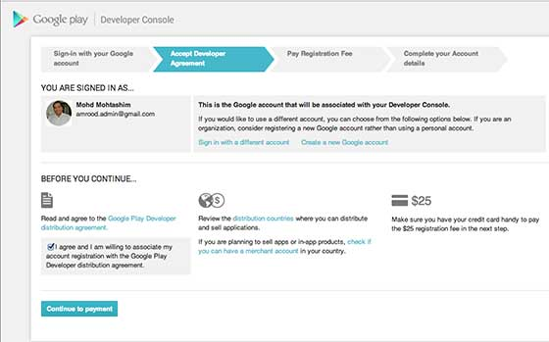

1. **Familiarize yourself with Developer Console**

Developer console is starting point and main dashboard for publishing tools and operations. Before you go ahead, familiarize yourself with list of merchant countries and developer countries. You need to review list of merchant countries if you want to sell apps or in app purchases or have subscriptions and list of developer countries will tell you about locations where distribution to Google play users is supported. Apart from this, also looks the Google Play’s Terms and conditions.

1. **Fill in the necessary account details**

After this, you have to provide your complete account details like you have to provide your developer name, the name which would be displayed in Google Play Store. You will have to wait for anything between just a little and 48 hours, after filling the details for Google play developer registration to be processed.

1. **Link your merchant account**

If you have a paid app or subscription or in app purchases, then you have to inter link your Google payments merchant account and developer profile. It can be used for tax and financial identification as well as monthly payout from sale.

1. **Upload your app**

When you assign in your Google Play developer console, click on “Add new application” from “All Applications tab”. After this select correct “Default Language” from drop down menu and then type “title” of your app which would be appear on Google Play store. Then, select “Upload APK” button to view on new page which would be your homepage for app. Time taken to upload file depend on your app size. App will be in drafts until or unless you publish it.

1. **Alpha and beta testing of app**

It is essential to test it with sample of end users to get feedback of app before launch your app even Google play take care of this as well. In section of your app “APK” of developer console, you will find option related to “Alpha Testing” and “Beta Testing”. After you uploaded your app’s “APK” file you can use these options for receive URL that can be shared with testers. By using this link, Testers can download app beta or alpha version. Your testers can not provide reviews and feedback on app page. Now you use this feedback to make relevant changes and optimize your app before publishing in app store.

1. **Provide details for store listing**

After uploading “APK” file go to “Store listing” tab. Over there you need to add details of app like “Full description” and “Short description”. Along with this add categorization, contact details, link of promo video if you have, add screenshots and other necessary details to app. After complete mandatory fields click on “Save” button. You can update your store listing anytime.

1. **Add pricing and distribution details**

Now move on next tab, which is “Pricing and Distribution” and select it is “Paid” or “Free” app. You also select distribution countries and check boxes stating your app complies with content guidelines. If your app is a game one, then you can put in limelight using “Google Play for Game” option. Now save changes and move on next step.

1. **Publishing the application**

When all three tabs “Pricing and Distribution”, “Store Listing” and “APK” have been filled then appear a green check mark next to them you are all ready to publish app in Google Play. After then click on “Publish this app” button under “Ready to Publish” drop down menu at top right corner of Developer console. A confirmation bar would show up stating your app would appear shortly in Google Play Store.

**10. Device Filtering option**

There are series of extra option that might not seem to be important to publish the app but they can prevent app from negative feedback. There is also option to manually filter non compatible devices or problematic so make the most use of it to filter out any negativities and stay on the top.

**ANDROID DEVELOPMENT LIFE CYCLE**

Once you developed and fully tested your Android Application, you can start selling or distributing free using Google Play (A famous Android marketplace). You can also release your applications by sending them directly to users or by letting users download them from your own website.

You can check a detailed publishing process at Android official website, but this tutorial will take you through simple steps to launch your application on Google Play. Here is a simplified check list which will help you in launching your Android application –

|  |  |
| --- | --- |
| **Step** | Activity |
| 1 | Regression Testing Before you publish your application, you need to make sure that it’s meeting the basic  Quality expectations for all Android apps, on all of the devices that you are targeting. So perform all the required  Testing on different devices including phone and tablets. |
| 2 | Application Rating When you will publish your application at Google Play, you will have to specify a content  Rating for your app, which informs Google Play users of its maturity level. Currently available ratings are (a)  Everyone (b) Low maturity (c) Medium maturity (d) High maturity. |
| 3 | Targeted Regions Google Play lets you control what countries and territories where your application will be sold.  Accordingly you must take care of setting up time zone, localization or any other specific requirement as per the  targeted region. |
| 4 | Application Size Currently, the maximum size for an APK published on Google Play is 50 MB. If your app exceeds that size,  or if you want to offer a secondary download, you can use APK Expansion Files, which Google Play  will host for free on its server infrastructure and automatically handle the download to devices. |
| 5 | SDK and Screen Compatibility It is important to make sure that your app is designed to run properly on the Android  platform versions and device screen sizes that you want to target. |
| 6 | Application Pricing Deciding whether you app will be free or paid is important because, on Google Play, free  app's must remain free. If you want to sell your application then you will have to specify its price in different currencies. |
| 7 | Promotional Content It is a good marketing practice to supply a variety of high-quality graphic assets to showcase your app or brand. After you publish, these appear on your product details page, in store listings and search results, and elsewhere. |
| 8 | Build and Upload release-ready APK The release-ready APK is wheat you will upload to the Developer Console and  distribute to users. You can check complete detail on how to create a release-ready version of your app: [Preparing for Release](https://developer.android.com/tools/publishing/preparing.html). |
| 9 | **Finalize Application Detail** Google Play gives you a variety of ways to promote your app and engage with users on your product details page, from colourful graphics, screen shots, and videos to localized descriptions, release details, and links to your other apps. So you can decorate your application page and provide as much as clear crisp detail you can provide.  **The Google Play Developer API**  The Google Play Developer API is a REST-based web service that allows you to perform publishing and app-management tasks. You can use this API to integrate your publishing operations with your release-management process.  Not all developers will need to use these APIs—in most cases you will continue to manage your apps directly using the Google Play Console. However, if you have a large number of APKs to manage, or have to track user purchases and subscriptions, you may find this API very useful.  Using the Google Play Developer API, you can automate a variety of app-management tasks, including:   * Uploading and releasing new versions of your app * Editing your app Google Play Store listings, including localized text and graphics * Managing your in-app product catalog, your products purchase status and your app subscriptions |

**Google Play Registration**

The most important step is to register with Google Play using [Google Play Marketplace](https://play.google.com/apps/publish/" \t "_blank). You can use your existing Google ID if you have any otherwise you can create a new Google ID and then register with the marketplace. You will have following screen to accept terms and condition.

Once you are a registered user at Google Play, you can upload **release-ready APK** for your application and finally you will complete application detail using application detail page as mentioned in step 9 of the above mentioned checklist.

SIGNING YOUR APP MANUALLY

You do not need Android Studio to sign your app. You can sign your app from the command line using standard tools from the Android SDK and the JDK. To sign an app in release mode from the command line −

* Generate a private key using key tool

$ Key tool -genkey -v -keystore my-release-key.keystore

-Alias alias name -keyalg RSA -key size 2048 -validity 10000

* Compile your app in release mode to obtain an unsigned APK
* Sign your app with your private key using [jar signer](https://docs.oracle.com/javase/6/docs/technotes/tools/windows/jarsigner.html)

$ Jar signer -verbose -sigalg SHA1withRSA -digestalg SHA1

-key store my-release-key.keystore my\_application.apk alias name

* Verify that your APK is signed. For example −

$ Jar signer -verify -verbose -certs my\_application.apk

* Align the final APK package using [zip align.](https://developer.android.com/tools/help/zipalign.html)
* $ Zip align -v 4 your\_project\_name-unaligned.apk your\_project\_name.apk

**SOME OF APP MARKETS**

* [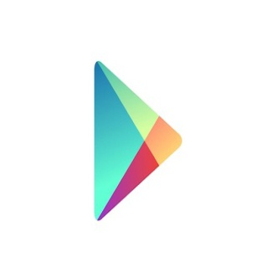](https://play.google.com/store)

**GOOGLE PLAY**

* [](http://www.phoload.com/)

**PHOLOAD**

* [F:\Publishing Android Application_files\logotipo-e1424956156930.png](https://m.aptoide.com/installer)

**m,APTOIDE**

* [](https://www.amazon.com/mobile-apps/b?node=2350149011)

**AMAZON APPSTORE**

* [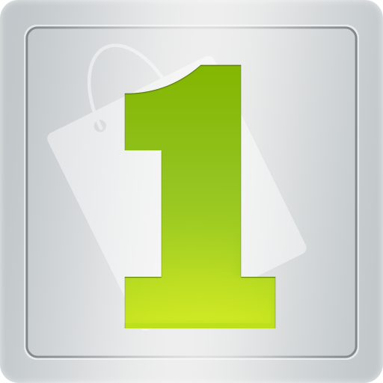](https://www.1mobile.com/)

**1MOBILE**

* [](http://www.insydemarket.com/)